**PERFORM USER REQUIREMENTS:** **SMART RIDE ANALYTICS SYSTEM**

**DQL (Data Query Language):**

1. **Retrieve all users**

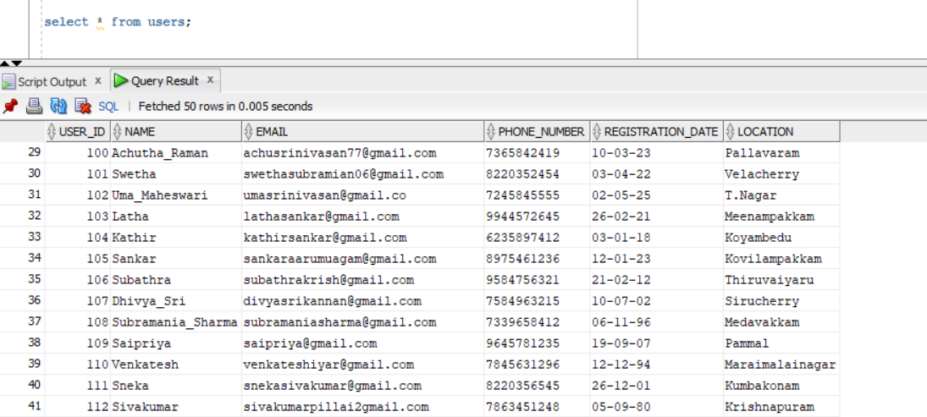

1. **Get the total number of rides completed**



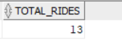

1. **Find the highest fare paid for a ride**





1. **Retrieve all vehicle details for a specific type (e.g., Car)**



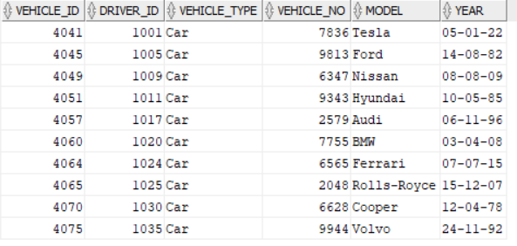

1. **List rides with user details and driver details**

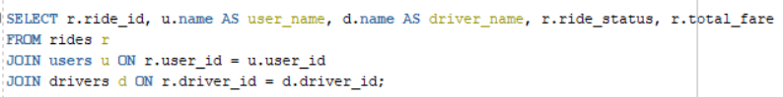

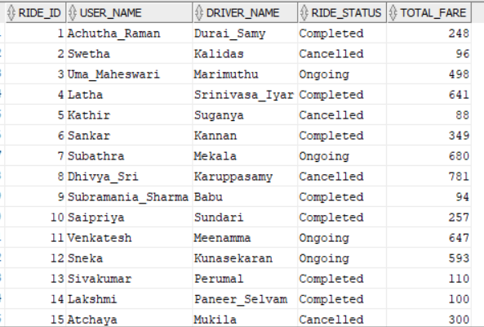

1. **Calculate total earnings of each driver**

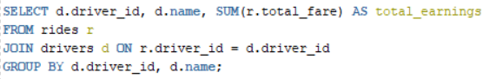

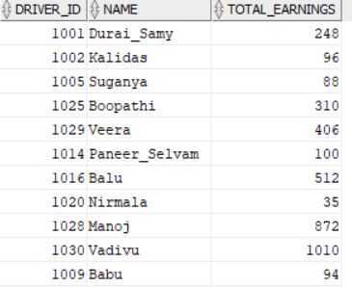

1. **Find the average rating for each driver**

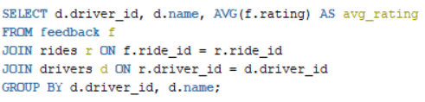

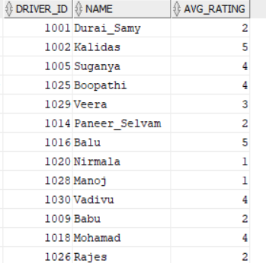

1. **Retrieve all rides for a specific user, ordered by ride date**

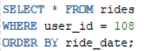



1. **Find the total revenue generated from rides**





1. **Find the drivers who haven't received any feedback**

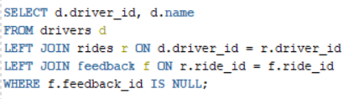

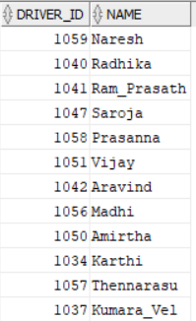

1. **List all rides where fare is above average fare**



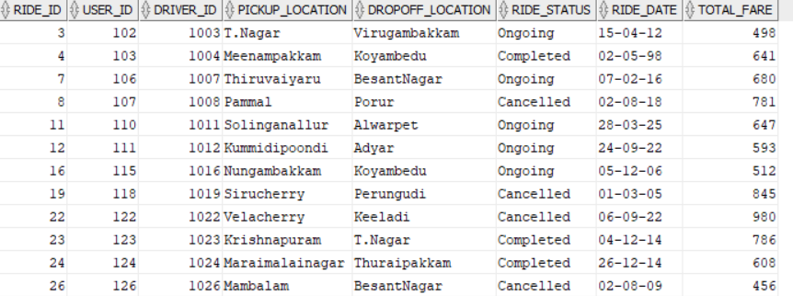

1. **Count rides per day with TO_CHAR function**

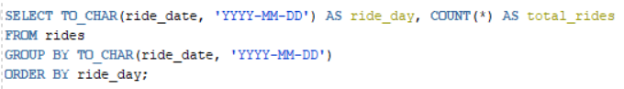

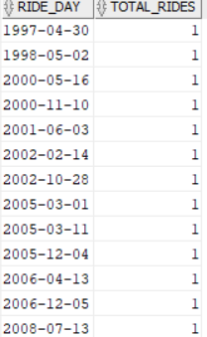

1. **Get the length of driver names using LENGTH function**

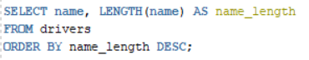

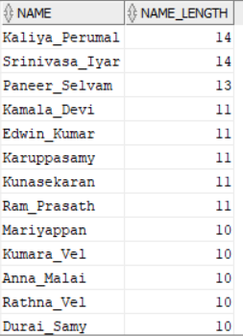

1. **Count feedback ratings per ride status using NVL function**

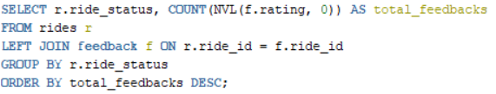

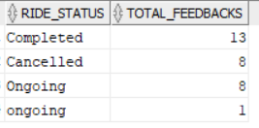

1. **Find users registered in the last 30 days using SYSDATE function**

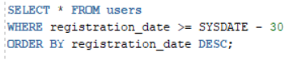

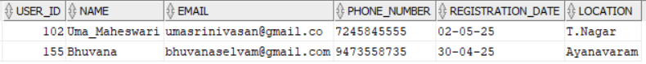

1. **Get the lowest fare per ride status using MIN function**

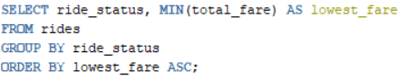

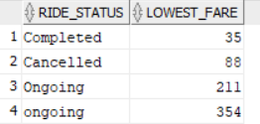

1. **Get the highest and lowest ride fare using MAX & MIN functions**





1. **Get payment details with INITCAP function to format payment methods**

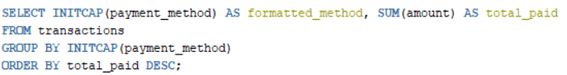

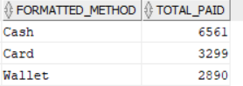

1. **Retrieve all transactions for a specific ride**





1. **Find Rides Taken Between Two Dates**



